

Dynamics 365 – BoM Part Rev Change
Revision 1
Revision History

Date | Revision | Description | Signature / Date
03/10/2022 | 1 | Initial draft of user manual: Dynamics 365 – BoM Part Rev Change | Prepared | Waseem Abbas
 |  |  | Verified
 |  |  | Approved
 |  |  | Prepared
 |  |  | Verified
 |  |  | Approved
 |  |  | Prepared

Table of Contents
1 About User Manual 5
1.1 Dashboard Overview 5
2 Bom Part Rev Change 5
2.1 Add Assembly Number 6
2.2 Get BoM Parts 6
2.3 Replace Part Version 7

List of Figures
Figure 1. Dashboard Overview 5
Figure 2. BoM Part Rev Change 5
Figure 3. Add Assembly Number to Get BOM Part 6
Figure 4. Confirmation Popup to Get BOM Parts 6
Figure 5. Get BoM Parts 7
Figure 6. Replace Version 7

About User Manual
This document describes the step-by-step guide of getting the BoM part and replace it of the top assembly number. These top assembly number are typically created by a purchase user (employee) in a legal entity (legal organization). The purchase user selects the assembly and get its BoM parts then user can replace the part variant.
The step-by-step guide of a BoM Part Rev Change will be explained.

Dashboard Overview
After logging in, you will see the main dashboard which includes the grid of individual Workspaces (in the middle), which are represented in the Figure 1.
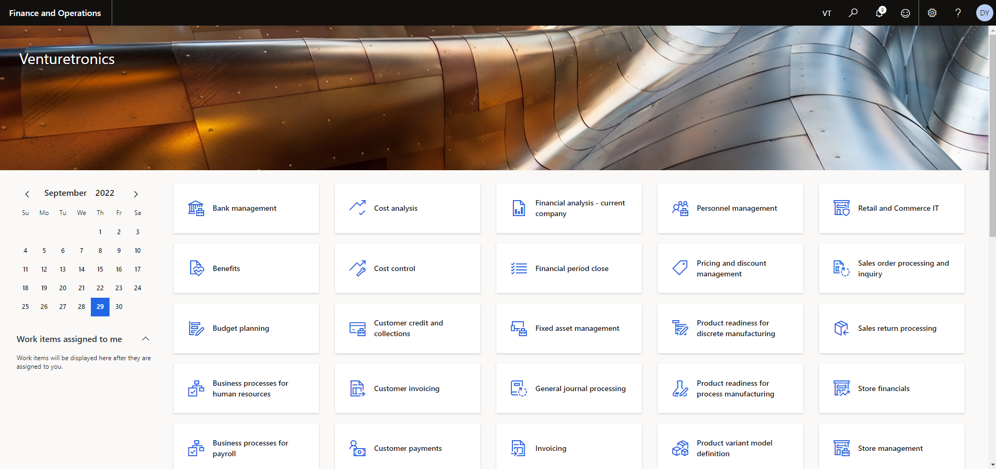
Figure 1. Dashboard Overview

Bom Part Rev Change
As a first step to open the product information management from the module and click on BoM Part Rev Change which have been shown in Figure 2.
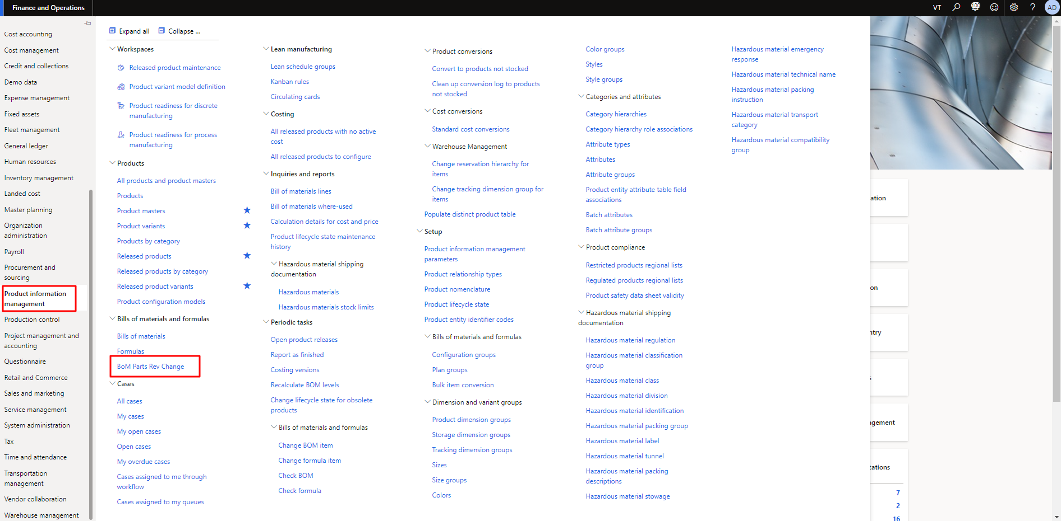
Figure 2. BoM Part Rev Change

Add Assembly Number
As step 1, the purchase user can access the BoM Part Rev Change by clicking on it. After the user clicks on it, the user needs to fill the field (Top Assembly Number) as per requirements and then click on Get BOM Part to get the BoM parts. The process is also shown in the Figure 3.
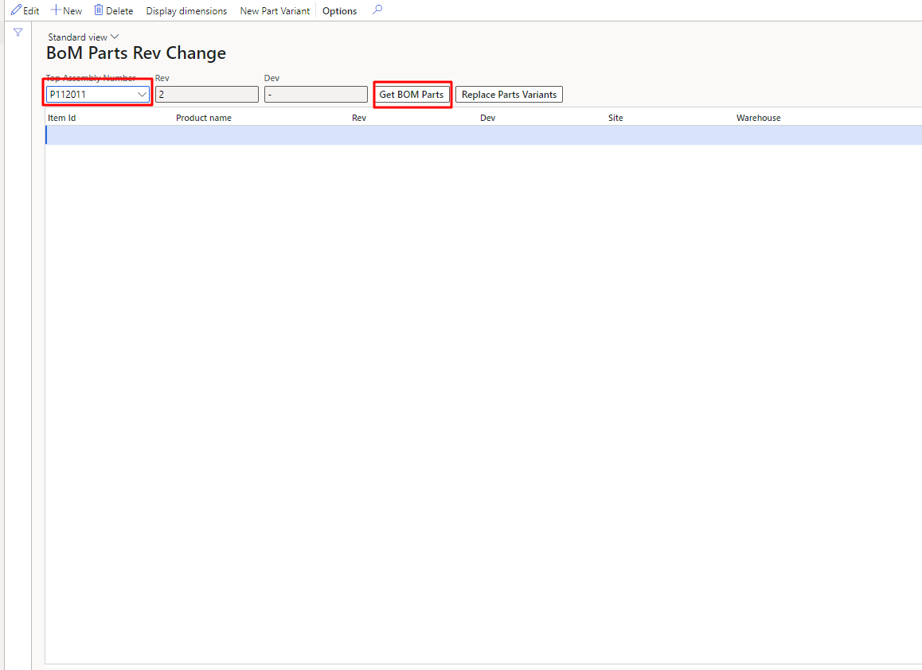
Figure 3. Add Assembly Number to Get BOM Part
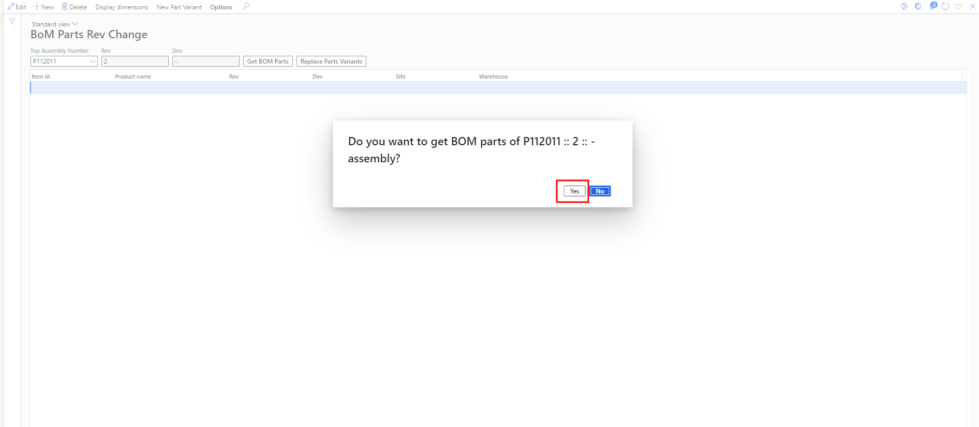
Figure 4. Confirmation Popup to Get BOM Parts

Get BoM Parts
In step 2, the purchase user can access the BoM Part Rev Change by clicking on it. As the user clicks on it, user needs to fill the field (Top Assembly Number) as per requirements and then click on Get BOM Part to get the BoM parts. The process is also shown in the Figure 5.
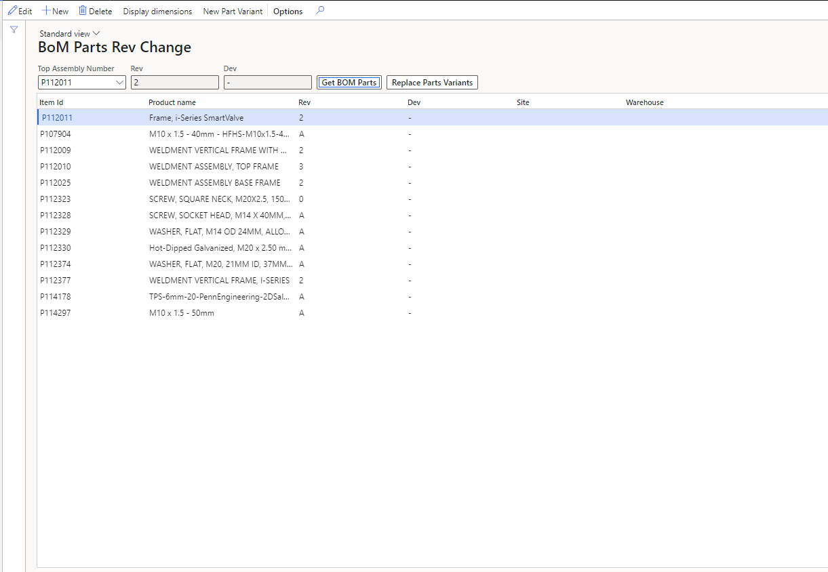
Figure 5. Get BoM Parts

Replace Part Version
As step 13, the purchase user can access it to get BoM Parts. The user can change the Rev of assembly by following the Rev of it. The process is also shown in the Figure 6.
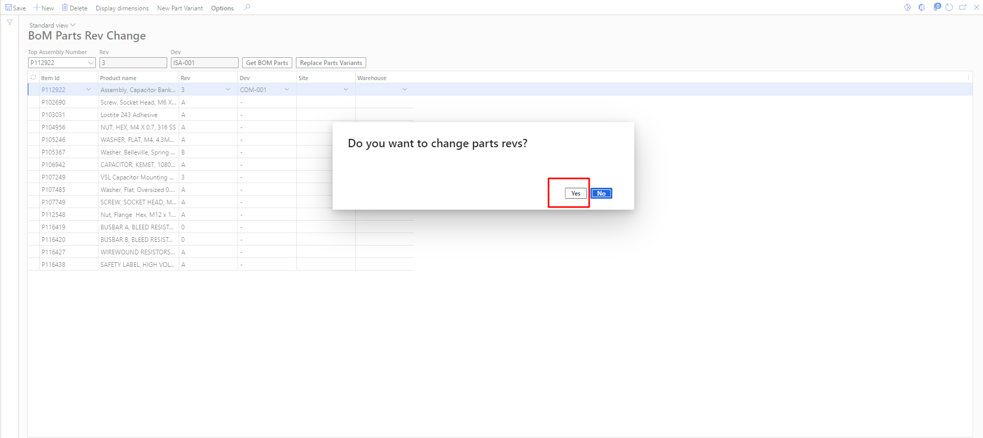
Figure 6. Replace Version

